eVTOL 비행체의 Tele-Operation을 위한 Digital Twin Control Frame 아키텍처 구축

곽태호1*, 현정석1, 장민석1, Tuan Anh Nguyen1, 이재우1

건국대학교 항공우주설계∙인증연구소1

Establishment of Digital Twin Control Frame Architecture for eVTOL Tele-Operation

Taeho Kwag1*, Jeongseok Hyun1, Minseok Jang 1, Tuan Anh Nguyen1 and Jae-Woo Lee1

━━━━━━━━━━━━━━━━━━━━━━━━━━━━━━━━

**Key Words** : Digital Twin(디지털 트윈), Tele-Operation, Flight Simulation(비행 시뮬레이션), eVTOL(Electric Vertical Take-Off and Landing), UAM(도심항공 모빌리티), UAS(무인 항공기 시스템)

서 론

Urban Air Mobility (UAM) is essential to secure safety because it is operated at a low altitude in urban areas where population and property are concentrated. A very high level of flight safety guarantees are required for remote/autonomous flight phases without pilots, especially as the goal is to achieve growth ground-based remote control and mature autonomous flight in line with technology and industry maturity. Therefore, digital twin systems are drawing attention as platform technologies across the UAM operation life cycle, from development and verification of electric vertical take-off and landing (eVTOL) aircraft used for UAM operation to support safe operation. A key element for implementing a digital twin system is the implementation of an interaction between a physical layer's actual aircraft configured with a dynamic operating environment and a digital object (digital replica) in a digital layer configured with a high-fidelity virtual environment.

In this work, we present a control frame based on digital twin technology to apply the concept of Tele-Operation utilized in the existing robotics field to UAM remote operation. A Digital Twin Control Frame (DTCF) architecture that can remotely control eVTOL aircraft through a digital replica built with high-precision SITL simulation was constructed, and a communication interface using MAVLink was developed to test the system.

본 론

Tele-Operation Technologies

The concept of Tele-Operation, classified as a remote system, differs from the concept of remote operation commonly applied in existing unmanned aerial systems and remote piloted aerial systems. Although the purpose of real-time monitoring and control of the gas through radio communication in a ground control station (GCS) separate from the operating target, Tele-Operation is the same as the common remote operation, the operator sends direct control commands to the distant target gas (Fig.The operation target is controlled (Fig.1B) by interaction with the simulated object, not 1A).[1] This enables the operator to accurately recognize the situation with a high sense of immersion, precisely control, and secure safety from control and danger even if the object is at a long distance from the non-visible area.

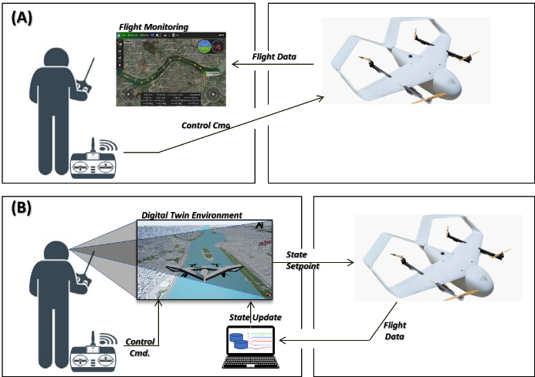

Fig. 1. Concept of Tele-Operation

Therefore, the purpose of DTCF implementation is to use simulation objects in a digital twin environment as a simulation means for the application of Tele-Operation technology in the operation of an eVTOL aircraft that performs dynamic 6-degree of freedom in a three-dimensional airspace environment.

Digital Twin Control Frame Architecture

The interaction-based digital twin implementation architecture between the physical layer (eVTOL) and the simulation-based digital replica (Digital Layer) operating in the real world is shown in Fig. It is equal to two.

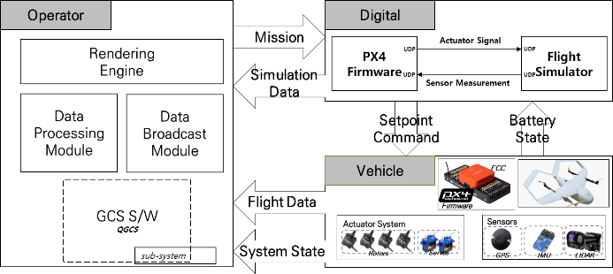

Fig. 2. DTCF Data Flow

Operators on the ground receive visualization feedback from 3D maps and flight data in digital twin environments through rendering engines, monitoring the current state and controlling the aircraft. It also performs interaction between two-layer objects through an object-to-object data exchange interface module composed of script programs. The Digital Layer consists of a high-precision flight dynamics model simulation to simulate the state of eVTOL and a digital replica integrated with the software-in-the-loop (SITL) interface of flight control firmware, which performs real-time flight simulations and transfers status data to the data exchange module. The physical layer's eVTOL is based on a UAS system that includes Pixhawk FCC loaded with PX4 firmware, motor and servo actuators, sensors and radio telemetry, and receives status data from digital replicas in real time and transmits actual sensor data.

Fig. 3. Twin Data Intermediary Module

The communication interface for the interaction between the eVTOL of the physical layer and the digital replica of the digital layer was implemented in the form of a Python script using MAVLink, a private UAS standard protocol. The connection to the Digital Layer is a UDP socket port, and the eVTOL of the Physical Layer is a serial port through telemetry, which is connected to the data exchange module. The simulation data received from the digital replica is buffered through MAVLink packet decode, storing the location, speed, acceleration, and posture of the NED Local Frame and authorizing it as a real-time Setpoint command to the eVTOL in flight.

비행시험을 통한 검증

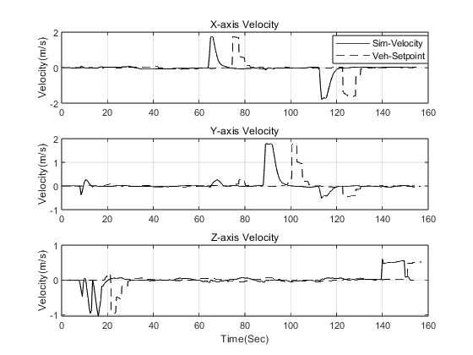

Fig. 4. Flight Test Result

The graph is speed data of a simulated NED frame from a digital replica and log data transmitted/input to Setpoint in an eVTOL in flight. As a result of the flight test, it was confirmed that the remote control input was accurately transmitted through the DTCF and the communication interface.

결 론

In this study, a DTCF architecture was constructed to remotely control the aircraft of the physical layer through operator-digital layer interaction to apply the concept of Tele-Operation based on UAM digital twin technology. As a result of conducting a flight test on the constructed architecture, it was confirmed that the simulation status data was accurately input to the Setpoint of the eVTOL in flight. However, due to the performance limitations of the possessed communication equipment, it is confirmed that delays have occurred in the delivery of control commands, requiring future supplementary development.

후 기

이 연구는 서울시의 “서울형 도심항공교통(UAM) 도입 기본계획수립 연구용역”의 일부로 수행되었으며, 국토교통부/국토교통과학기술진흥원의 지원 (과제명 미래형 자율비행 개인항공기 인증 및 안전 운항기술 개발 과제번호: 23ACTO-B151661-05)과 2020년도 정부(교육부)의 재원으로 한국 연구재단의 지원 (No. 2020R1A6A1A03046811)을 받아 수행된 기초연구 사업임.

참고문헌

1) H. Chen, F. Liu, Y. Yang and W. Meng, "MultiVR: Digital Twin and Virtual Reality Based System for Multi-people Remote Control Unmanned Aerial Vehicles," *2022 17th International Conference on Control, Automation, Robotics and Vision (ICARCV*), 2022, pp. 647-652